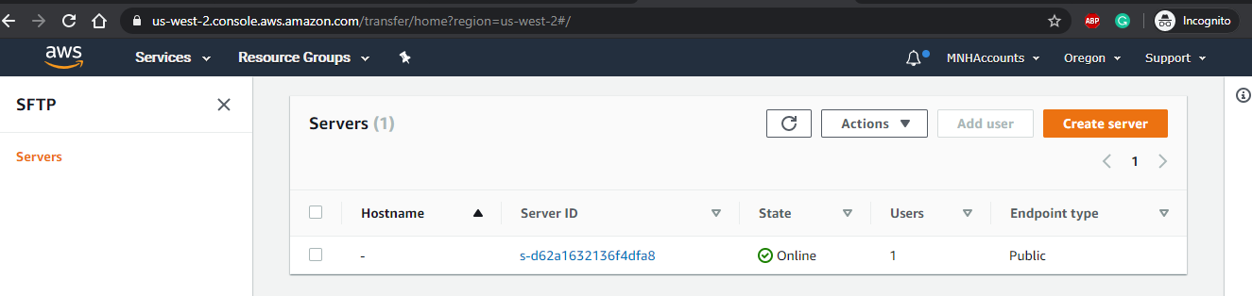

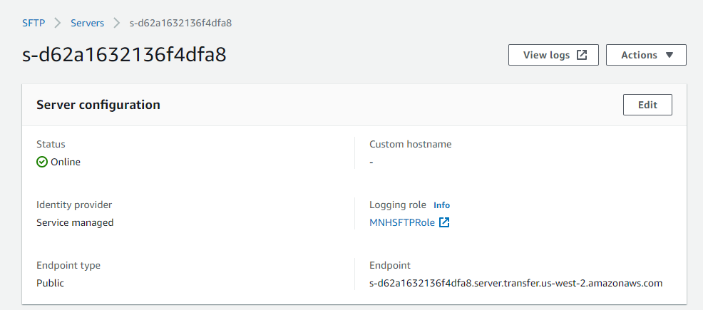

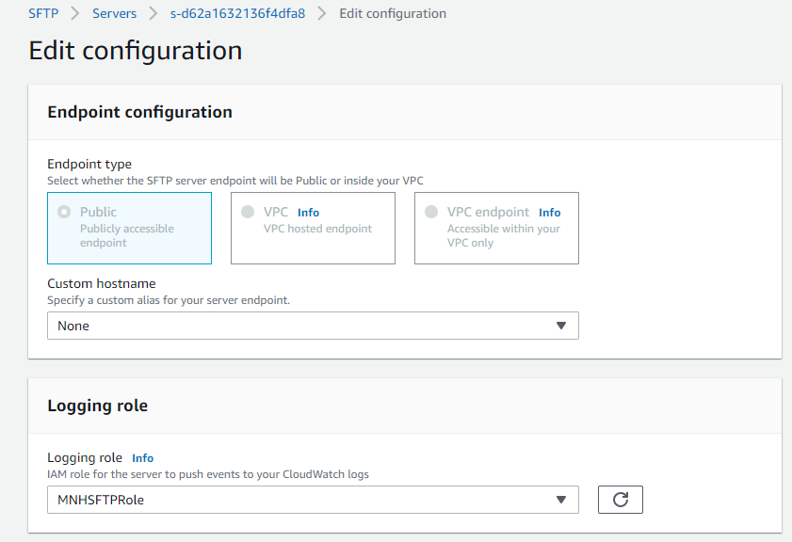
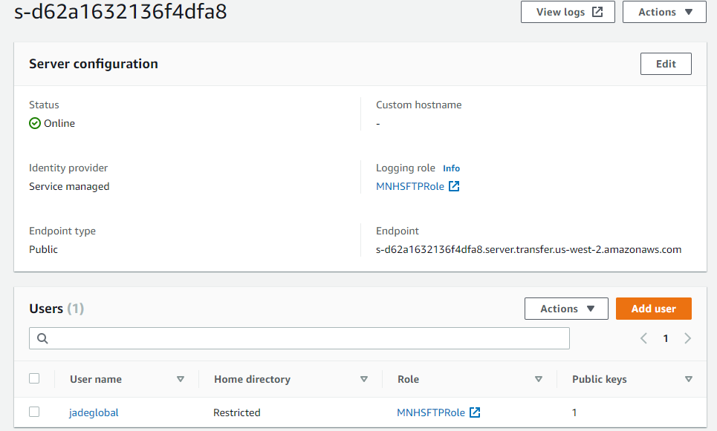

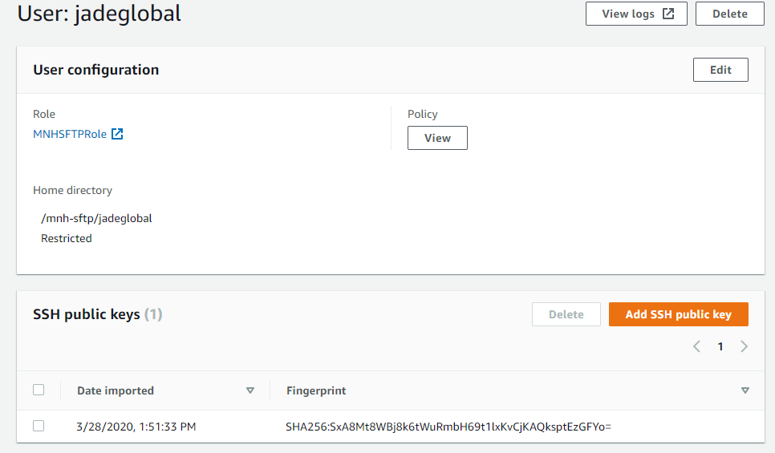

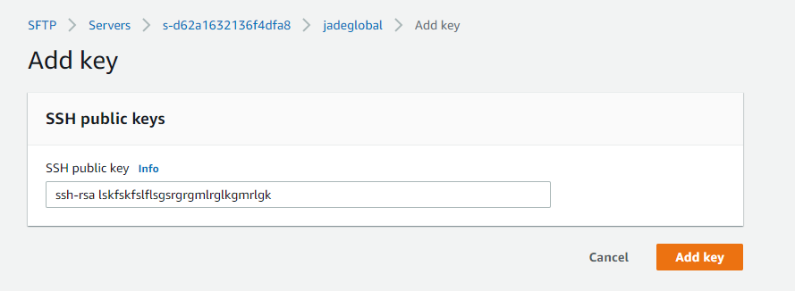
MNH SFTP Policy:
{
"Version": "2012-10-17",
"Statement": [
{
"Effect": "Allow",
"Action": [
"s3:GetBucketLocation",
"s3:ListAllMyBuckets"
],
"Resource": "*"
},
{
"Effect": "Allow",
"Action": [
"s3:ListBucket"
],
"Resource": [
"arn:aws:s3:::mnh-sftp"
]
},
{
"Effect": "Allow",
"Action": [
"s3:PutObject",
"s3:GetObject"
],
"Resource": [
"arn:aws:s3:::mnh-sftp/*"
]
}
]
}

MNHSFTPRole-Trust Relationship:
{
"Version": "2012-10-17",
"Statement": [
{
"Sid": "",
"Effect": "Allow",
"Principal": {
"Service": "transfer.amazonaws.com"
},
"Action": "sts:AssumeRole"
}
]
}

MNHSFTPScopeDownPolicy:
{
"Version": "2012-10-17",
"Statement": [
{
"Sid": "AllowListingOfUserFolder",
"Action": [
"s3:ListBucket"
],
"Effect": "Allow",
"Resource": [
"arn:aws:s3:::${transfer:mnh-sftp}"
],
"Condition": {
"StringLike": {
"s3:prefix": [
"${transfer:HomeFolder}/*",
"${transfer:HomeFolder}"
]
}
}
},
{
"Sid": "HomeDirObjectAccess",
"Effect": "Allow",
"Action": [
"s3:PutObject",
"s3:GetObject"
],
"Resource": "arn:aws:s3:::${transfer:jadeglobal}*"
}
]
}

Adding New User:

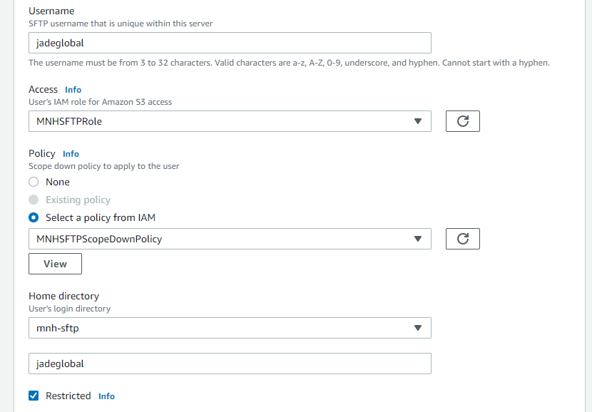

MNH S3 – SFTP Bucket:
